Americana Keyhole Scarf, Bunting Style
FREE knitting pattern - for FiberKind Marketplace: Americana Keyhole Scarf, Bunting Style

This Americana Keyhole Scarf has two keyholes, and short ruffled tails reminiscent of draped, pleated flag bunting.
This knitting pattern is a collection of design and construction notes for this patriotic scarf.
This scarf is made with two skeins of yarn:
- the short ruffled tails which form the "bunting" are knit with Red Heart Super Saver yarn in the self-striping colorway Americana.
- the main part of the scarf (which includes the keyholes and the portion which wraps around the neck) may be worked in any worsted weight yarn, such as Hobby Lobby's "I Love This Yarn" in the colorway red metallic. This acrylic yarn has a soft, pliable, silvery metallic thread to add a touch of sparkle without being scratchy or irritating to the skin. I found it to be easy on the hands to work with.

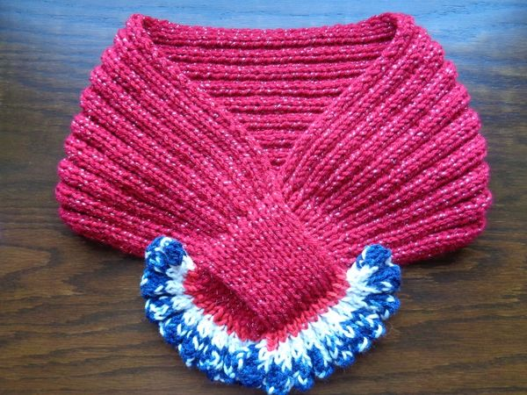
This bunting-style design variation utilizes a few more techniques than the basic Americana Keyhole Scarf:
Cast on
Knit stitch
Purl stitch
Slip stitch
Combination of Knit and Purl stitches: 1x1 ribbing, 2x2 ribbing
Increase (knit 1 below)
Decrease (k2tog, p2tog)
Bind off
What you need:
1 skein of Red Heart Super Saver “Americana” yarn + one skein of worsted weight acrylic yarn of your choice
1 set of knitting needles, US size 8 (5 mm) or size you are comfortable with for number “4” worsted weight yarn
1 stitch holder or small circular needle, for dividing alternating stitches for keyhole
1 small scissors
1 tapestry needle or crochet hook, to weave in ends
About 10 hours of time (will vary depending upon knitting skills, experience, speed, and size of scarf)

Prepare:
For the ruffle on the beginning tail:
Pull from skein of Red Heart Super Saver Americana yarn a single length of yarn which contains:
1 red stripe, 1 white stripe, 1/2 field of navy.
Gently wind this (not tightly) into a ball with the red at the center and the navy to the outside.

For the ruffle on the ending tail:
Pull length of matching yarn for second ruffle.
Gently wind this (not tightly) into a ball with the navy at the center and the red to the outside, and set aside.

While your gauge, needle size, and stitch counts may vary, here are the basic notes and stitch counts for how I knit this bunting-style variation of the Americana Keyhole Scarf:

First Ruffle:
Beginning with navy field… using long-tail cast on method and a tail of about 55 inches of the navy field … cast on 80 stitches in K4, P4 pattern using US size 6 (4mm) needle. Turn.
Row 1: K4, P4 across row. Turn.
Row 2: Decrease 80 stitches to 60: (K1, K2tog, K1) (P1, P2tog, P1) across row. Turn.
Row 3: K3, P3 across row. Turn.
Row 4: Decrease 60 stitches to 40: (K1, K2tog) (P1, P2tog) across row. Turn. [navy field ends… yarn is white]
Row 5: K2, P2 across row. Turn. [could repeat this row once]
Row 6: Decrease 40 stitches to 20: (K2tog) (P2tog) across row. Turn.
Row 7: K1, P1 across row. Turn. [white field ends… yarn is red]
Repeat row 7 to end of last full row possible with red yarn.
20 stitches.

First Keyhole:
Knit 2 rows with your main color.
Divide stitches as in basic Americana Keyhole Scarf pattern.
10 stitches.
First side of first keyhole:
Row 1: (K1, Purl 1 below) to end of row.
20 stitches.
Continue knitting 1st side of keyhole in 1x1 ribbing.
Second side of first keyhole:
Same as first side of first keyhole.
Close first keyhole:
(K1 from front needle, K1 from back needle (stitch holder or small circular needle), P1 from front needle, P1 from back needle) to end of row. Turn.
40 stitches.

Neck:
Knit length around neck in 2x2 ribbing.
For comfort, consider knitting 2-3 inches of ease (longer than the neck measurement of the intended wearer).

Second Keyhole:
Divide stitches as in basic Americana Keyhole Scarf pattern.
20 stitches.
First side of second keyhole:
Work in 1x1 ribbing.
Second side of keyhole:
Same as first side of second keyhole.
Close second keyhole:
(K1 from front needle together with 1 from back needle (stitch holder or small circular needle), P1 from front needle together with 1 from back needle) to end of row. Turn.
20 stitches.

Ending Ruffle:
Beginning with red stripe, and paying attention to when the colors changed (navy-white-red) on the first ruffle:
Row 1-1x: K1,P1 across row. Turn. Note: x is a variable... for example, it may be 1, 2, or 3 rows depending on your gauge.
Row 2: Increase 20 stitches to 40: (K1, K1 below) (P1, P1 below) across row. Turn.
Row 3: K2, P2 across row. Turn.
Row 4: Increase 40 stitches to 60: (K1, K1 below, K1) (P1, P1 below, P1) across row. Turn.
Row 5: K3, P3 across row. Turn.
Row 6: Increase 60 stitches to 80: (K2, K1 below, K1) (P2, P1 below, P1) across row. Turn.
Row 7: K4, P4 across row. Turn.
Bind off.
Weave in ends.

Enjoy!

